<Online Flight Tracking System>

Software Modeling

<Phase 2>

<April 22, 2018>

<Abdulrhman Ali Alsenedi/436101804>

<Abdulmajeed Saleh Alaskar/436104024>

<Khalid Abdulhadi Alqahtani/434105057>

<Asim Mohammed Alali/435102899>

**Composite Diagram :**

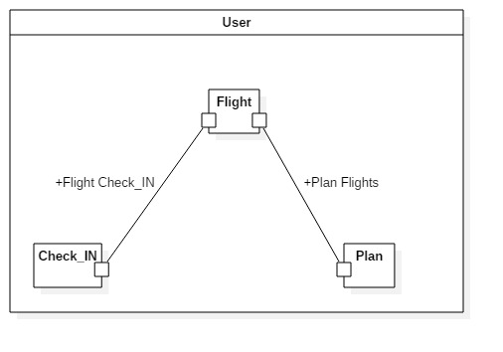

# We need composite diagram for User class because it is the point where to many classes join and communicate depending on event that’s trigger by User class

**Sequence Diagram & Communication for critical use cases :**

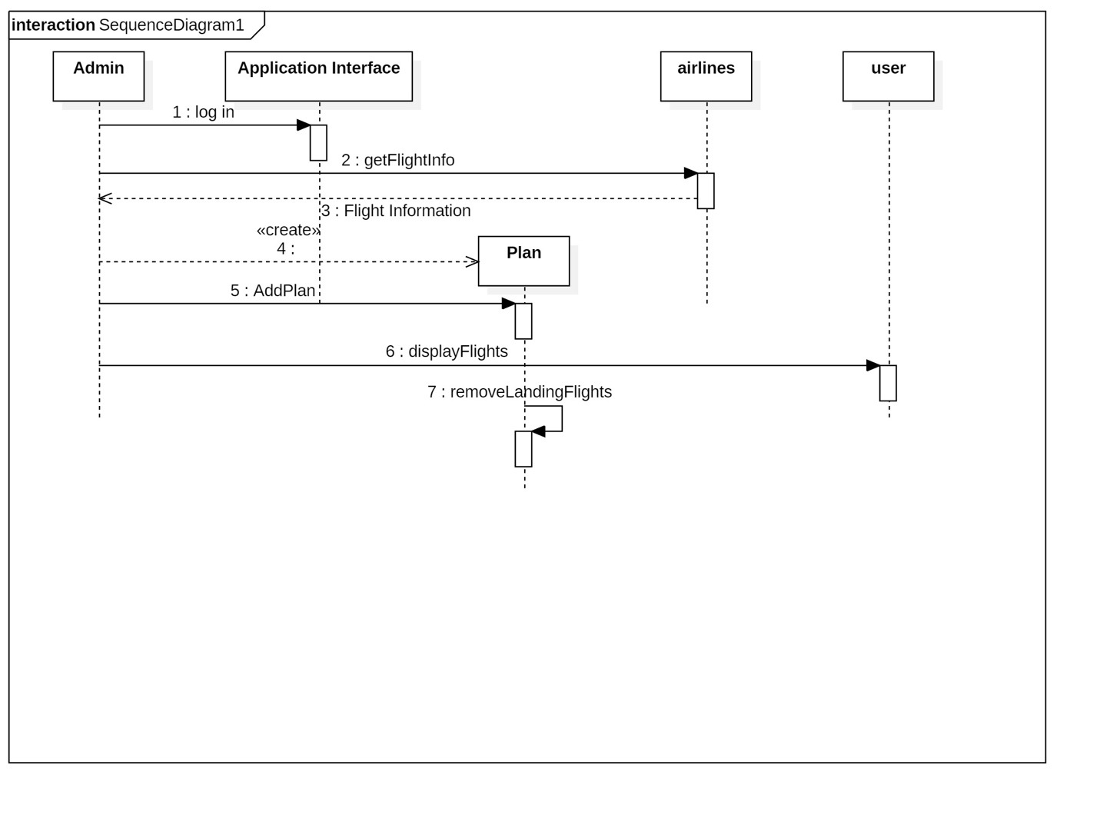

**State Diagram :**

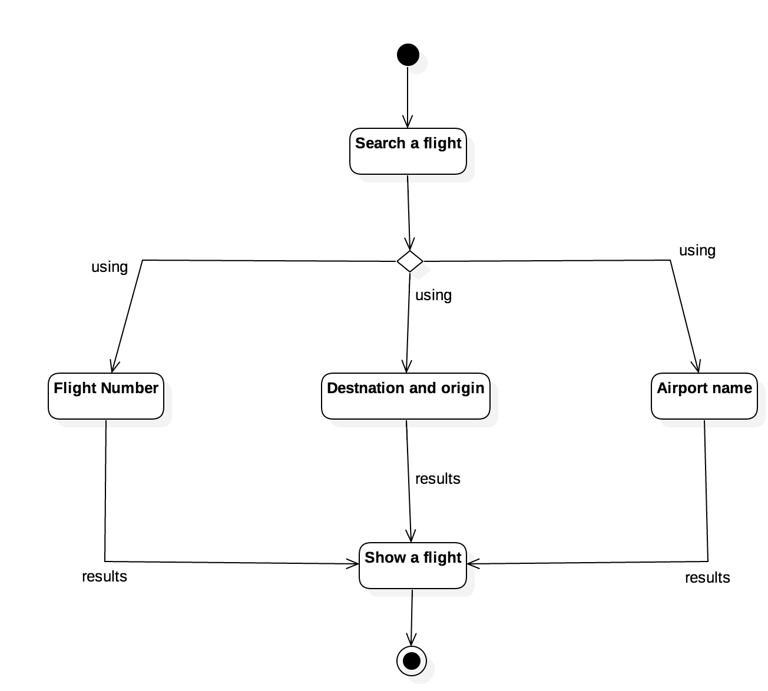

**Java Code Transformation:** 

Java Code Transformation

/**

*

*/

**import** java.util.Set;

/**

* <!-- begin-UML-doc -->

* <!-- end-UML-doc -->

* **@author** 36s467

* **@generated** "UML to Java (com.ibm.xtools.transform.uml2.java5.internal.UML2JavaTransform)"

*/

**public** **class** User {

/**

* <!-- begin-UML-doc -->

* <!-- end-UML-doc -->

* **@generated** "UML to Java (com.ibm.xtools.transform.uml2.java5.internal.UML2JavaTransform)"

*/

**private** Object Id;

/**

* <!-- begin-UML-doc -->

* <!-- end-UML-doc -->

* **@generated** "UML to Java (com.ibm.xtools.transform.uml2.java5.internal.UML2JavaTransform)"

*/

**private** Object name;

/**

* <!-- begin-UML-doc -->

* <!-- end-UML-doc -->

* **@generated** "UML to Java (com.ibm.xtools.transform.uml2.java5.internal.UML2JavaTransform)"

*/

**private** Set<Plan> plan;

/**

* <!-- begin-UML-doc -->

* <!-- end-UML-doc -->

* **@generated** "UML to Java (com.ibm.xtools.transform.uml2.java5.internal.UML2JavaTransform)"

*/

**private** Set<Check_In> check_In;

/**

* <!-- begin-UML-doc -->

* <!-- end-UML-doc -->

* **@generated** "UML to Java (com.ibm.xtools.transform.uml2.java5.internal.UML2JavaTransform)"

*/

**private** Set<Flight> flight;

/**

* <!-- begin-UML-doc -->

* <!-- end-UML-doc -->

* **@generated** "UML to Java (com.ibm.xtools.transform.uml2.java5.internal.UML2JavaTransform)"

*/

**public** **void** getName() {

// begin-user-code

// **TODO** Auto-generated method stub

// end-user-code

}

/**

* <!-- begin-UML-doc -->

* <!-- end-UML-doc -->

* **@generated** "UML to Java (com.ibm.xtools.transform.uml2.java5.internal.UML2JavaTransform)"

*/

**public** **void** setName() {

// begin-user-code

// **TODO** Auto-generated method stub

// end-user-code

}

/**

* <!-- begin-UML-doc -->

* <!-- end-UML-doc -->

* **@generated** "UML to Java (com.ibm.xtools.transform.uml2.java5.internal.UML2JavaTransform)"

*/

**public** **void** getID() {

// begin-user-code

// **TODO** Auto-generated method stub

// end-user-code

}

/**

* <!-- begin-UML-doc -->

* <!-- end-UML-doc -->

* **@generated** "UML to Java (com.ibm.xtools.transform.uml2.java5.internal.UML2JavaTransform)"

*/

**public** **void** setID() {

// begin-user-code

// **TODO** Auto-generated method stub

// end-user-code

}

}

=============================================================================

/**

*

*/

**import** java.util.Set;

/**

* <!-- begin-UML-doc -->

* <!-- end-UML-doc -->

* **@author** 36s467

* **@generated** "UML to Java (com.ibm.xtools.transform.uml2.java5.internal.UML2JavaTransform)"

*/

**public** **class** Plan {

/**

* <!-- begin-UML-doc -->

* <!-- end-UML-doc -->

* **@generated** "UML to Java (com.ibm.xtools.transform.uml2.java5.internal.UML2JavaTransform)"

*/

**private** Object planName;

/**

* <!-- begin-UML-doc -->

* <!-- end-UML-doc -->

* **@generated** "UML to Java (com.ibm.xtools.transform.uml2.java5.internal.UML2JavaTransform)"

*/

**private** Set<Flight> flight;

/**

* <!-- begin-UML-doc -->

* <!-- end-UML-doc -->

* **@generated** "UML to Java (com.ibm.xtools.transform.uml2.java5.internal.UML2JavaTransform)"

*/

**public** **void** setPlanName() {

// begin-user-code

// **TODO** Auto-generated method stub

// end-user-code

}

/**

* <!-- begin-UML-doc -->

* <!-- end-UML-doc -->

* **@generated** "UML to Java (com.ibm.xtools.transform.uml2.java5.internal.UML2JavaTransform)"

*/

**public** **void** getPlanName() {

// begin-user-code

// **TODO** Auto-generated method stub

// end-user-code

}

}

=============================================================================

/**

*

*/

/**

* <!-- begin-UML-doc -->

* <!-- end-UML-doc -->

* **@author** 36s467

* **@generated** "UML to Java (com.ibm.xtools.transform.uml2.java5.internal.UML2JavaTransform)"

*/

**public** **class** Check_In {

/**

* <!-- begin-UML-doc -->

* <!-- end-UML-doc -->

* **@generated** "UML to Java (com.ibm.xtools.transform.uml2.java5.internal.UML2JavaTransform)"

*/

**private** Object bookNum;

/**

* <!-- begin-UML-doc -->

* <!-- end-UML-doc -->

* **@generated** "UML to Java (com.ibm.xtools.transform.uml2.java5.internal.UML2JavaTransform)"

*/

**private** Flight flight;

/**

* <!-- begin-UML-doc -->

* <!-- end-UML-doc -->

* **@generated** "UML to Java (com.ibm.xtools.transform.uml2.java5.internal.UML2JavaTransform)"

*/

**public** **void** getBookNum() {

// begin-user-code

// **TODO** Auto-generated method stub

// end-user-code

}

/**

* <!-- begin-UML-doc -->

* <!-- end-UML-doc -->

* **@generated** "UML to Java (com.ibm.xtools.transform.uml2.java5.internal.UML2JavaTransform)"

*/

**public** **void** setBookNum() {

// begin-user-code

// **TODO** Auto-generated method stub

// end-user-code

}

}

=============================================================================

/**

*

*/

/**

* <!-- begin-UML-doc -->

* <!-- end-UML-doc -->

* **@author** 36s467

* **@generated** "UML to Java (com.ibm.xtools.transform.uml2.java5.internal.UML2JavaTransform)"

*/

**public** **class** Flight {

/**

* <!-- begin-UML-doc -->

* <!-- end-UML-doc -->

* **@generated** "UML to Java (com.ibm.xtools.transform.uml2.java5.internal.UML2JavaTransform)"

*/

**private** Object flightNum;

/**

* <!-- begin-UML-doc -->

* <!-- end-UML-doc -->

* **@generated** "UML to Java (com.ibm.xtools.transform.uml2.java5.internal.UML2JavaTransform)"

*/

**private** Object flightTime;

/**

* <!-- begin-UML-doc -->

* <!-- end-UML-doc -->

* **@generated** "UML to Java (com.ibm.xtools.transform.uml2.java5.internal.UML2JavaTransform)"

*/

**private** Object flightDate;

/**

* <!-- begin-UML-doc -->

* <!-- end-UML-doc -->

* **@generated** "UML to Java (com.ibm.xtools.transform.uml2.java5.internal.UML2JavaTransform)"

*/

**private** Object flightStatus;

/**

* <!-- begin-UML-doc -->

* <!-- end-UML-doc -->

* **@generated** "UML to Java (com.ibm.xtools.transform.uml2.java5.internal.UML2JavaTransform)"

*/

**private** **void** getFlightInformative() {

// begin-user-code

// **TODO** Auto-generated method stub

// end-user-code

}

/**

* <!-- begin-UML-doc -->

* <!-- end-UML-doc -->

* **@generated** "UML to Java (com.ibm.xtools.transform.uml2.java5.internal.UML2JavaTransform)"

*/

**public** **void** getFlightStatus() {

// begin-user-code

// **TODO** Auto-generated method stub

// end-user-code

}

/**

* <!-- begin-UML-doc -->

* <!-- end-UML-doc -->

* **@generated** "UML to Java (com.ibm.xtools.transform.uml2.java5.internal.UML2JavaTransform)"

*/

**public** **void** setFlightStatus() {

// begin-user-code

// **TODO** Auto-generated method stub

// end-user-code

}

/**

* <!-- begin-UML-doc -->

* <!-- end-UML-doc -->

* **@generated** "UML to Java (com.ibm.xtools.transform.uml2.java5.internal.UML2JavaTransform)"

*/

**public** **void** getFlightDate() {

// begin-user-code

// **TODO** Auto-generated method stub

// end-user-code

}

/**

* <!-- begin-UML-doc -->

* <!-- end-UML-doc -->

* **@generated** "UML to Java (com.ibm.xtools.transform.uml2.java5.internal.UML2JavaTransform)"

*/

**public** **void** setFlightDate() {

// begin-user-code

// **TODO** Auto-generated method stub

// end-user-code

}

/**

* <!-- begin-UML-doc -->

* <!-- end-UML-doc -->

* **@generated** "UML to Java (com.ibm.xtools.transform.uml2.java5.internal.UML2JavaTransform)"

*/

**public** **void** getFlightTime() {

// begin-user-code

// **TODO** Auto-generated method stub

// end-user-code

}

/**

* <!-- begin-UML-doc -->

* <!-- end-UML-doc -->

* **@generated** "UML to Java (com.ibm.xtools.transform.uml2.java5.internal.UML2JavaTransform)"

*/

**public** **void** setFlightTime() {

// begin-user-code

// **TODO** Auto-generated method stub

// end-user-code

}

/**

* <!-- begin-UML-doc -->

* <!-- end-UML-doc -->

* **@generated** "UML to Java (com.ibm.xtools.transform.uml2.java5.internal.UML2JavaTransform)"

*/

**public** **void** getFlightNum() {

// begin-user-code

// **TODO** Auto-generated method stub

// end-user-code

}

/**

* <!-- begin-UML-doc -->

* <!-- end-UML-doc -->

* **@generated** "UML to Java (com.ibm.xtools.transform.uml2.java5.internal.UML2JavaTransform)"

*/

**public** **void** setFlightNum() {

// begin-user-code

// **TODO** Auto-generated method stub

// end-user-code

}

}

=============================================================================

/**

*

*/

/**

* <!-- begin-UML-doc -->

* <!-- end-UML-doc -->

* **@author** 36s467

* **@generated** "UML to Java (com.ibm.xtools.transform.uml2.java5.internal.UML2JavaTransform)"

*/

**public** **class** flightInformativeGetter {

/**

* <!-- begin-UML-doc -->

* <!-- end-UML-doc -->

* **@generated** "UML to Java (com.ibm.xtools.transform.uml2.java5.internal.UML2JavaTransform)"

*/

**private** Object APIsAccessAuthorization;

/**

* <!-- begin-UML-doc -->

* <!-- end-UML-doc -->

* **@generated** "UML to Java (com.ibm.xtools.transform.uml2.java5.internal.UML2JavaTransform)"

*/

**public** **void** setAPIsAccessAuthorization() {

// begin-user-code

// **TODO** Auto-generated method stub

// end-user-code

}

/**

* <!-- begin-UML-doc -->

* <!-- end-UML-doc -->

* **@generated** "UML to Java (com.ibm.xtools.transform.uml2.java5.internal.UML2JavaTransform)"

*/

**public** **void** getAPIsAccessAuthorization() {

// begin-user-code

// **TODO** Auto-generated method stub

// end-user-code

}

}